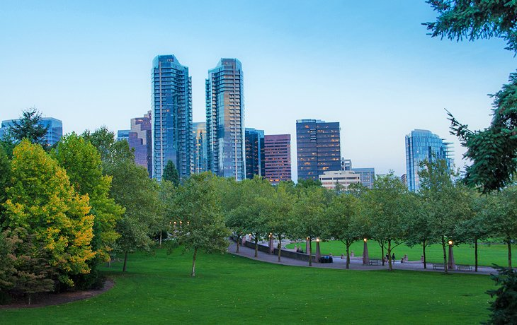
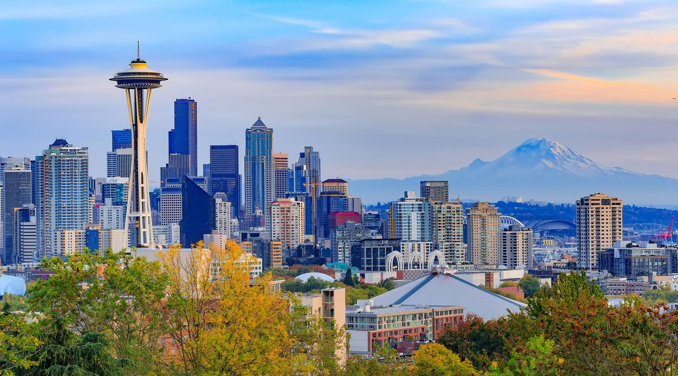

Bellevue, Washington
Seattle, Washington

36th Biennial Session if the Connectional Lay Organization
Transportation Options & Guidelines

Host District Transportation Options (Fill out Transportation Form to Request Transportation)
IMPORTANT DISCLAIMER: Everyone’s travel request is important to us. To better manage and sustain a successful travel program, we must place parameters around transportation services. The 36th Biennial Sessions begins with an Opening Service on June 30th and the first day of business begins July 1st, there will be limited transportation on those days. Therefore, if you will be requesting transportation from the 5th District, please adhere to the travel blocks and arrange your travel accordingly.
- Friday June 28th 12PM – 9PM from Arrival Destination to the Hotel Site
- Saturday June 29th 8AM – 9PM from Arrival Destination to the Hotel Site
- Sunday June 30th 9AM – 5PM from Arrival Destination to the Hotel Site
- Monday July 1st 8AM - 12PM from Arrival Destination to the Hotel Site
- Thursday July 4th 3PM – 9PM from Hotel to Departure Destination
- Friday July 5th 8AM – 5PM from the Hotel to Departure Destination

Bellevue Hyatt Hotel Transportation Options
- Arrange/Schedule a Shuttle Express through the hotel for $26.00 per person/one way. Please be informed that the Hotel’s Shuttle Express may make additional stops/pickups at other sites.
Booking Online: ShuttleExpress.com
Click Book Now and Provide Detailed Information
NOTE: The Shuttle Express offers the town car service for $75 for up to 3 people and no more than 4 checked bags and $95 for the SUV with up to 5 people and no more than 6 checked bags.
- Arrange/Schedule Eagle Town Car/Limousine Service for $85.00 from the airport to the hotel and $65.00 dollars from the hotel to the airport. Please note that there is an additional 20% fee.
Booking Direct: (206) 227-6004 – POC: Mintay
Booking through Hotel: (425) 462-1234 EXT 51 – POC: Any Concierges Available

Paid Public Transportation Options
- Uber Services - $50.00/$60.00 One Way: To use Uber Services, one must download the Uber App onto your smart/mobile phone. Depending upon time of day (traffic impacts) Uber’s fees may vary.
- Lyft Services - $40.00/$50.00 One Way: To use Lyft Services, one must download the Lyft App onto your smart/mobile phone. Depending upon time of day (traffic impacts) Lyft’s fees may vary.
- All Other Public Transportation (Taxi/Yellow Cab…etc.) – Cost May Vary, Please Inquire at Your Own Pace

Bellevue, Washington
Seattle, Washington

36th Biennial Session of the Connectional Lay Organziation
Transportation Request Form
NOTE: If you are requesting transportation services outside of the 5th District’s travel options, your request will not be acknowledged.
INSTRUCTIONS:
- Please type or print your information and return a completed copy to the Travel Team
- All travel requests for the 36th Biennial Session must be received by 5PM PST - June 10th, 2019
- Please complete ONE FORM PER TRAVELER. Do not combine more than one traveler per form

NAME: __________________________________________
CELL PHONE: __________________________________________
EMAIL: __________________________________________
ARRIVAL AIRLINE/BUS/TRAIN & NUMBER: __________________________________________

ARRIVAL BLOCK & TIME (See Below): __________________________________________
BLOCK AVAILABILITY FOR ARRIVALS
Friday June 28th 12AM – 9PM from Arrival to the Hotel Site
Saturday June 29th 8AM – 9PM from Arrival to the Hotel Site
Sunday June 30th 9AM – 5PM from Arrival to the Hotel Site
Monday July 1st 8AM – 12PM from Arrival to the Hotel Site

DEPARTURE AIRLINE/BUS/TRAIN & NUMBER: _________________________________________
DEPARTURE BLOCK & TIME (See Below): _________________________________________
Thursday July 4th 3PM – 9PM from Hotel to Departure
Friday July 5th 8AM – 5PM from the Hotel to Departure

Please return by June 10, 2019 the completed form via email to both:
Faye Brown: (206) 851-9521 & Bobby Brown: (206) 724-9175
36biennialtransportation@gmail.com
UPON RETRIEVING YOUR BAGS – FOLLOW THE INSTRUCTIONS OF THE GREETERS AND GATHER OUTSIDE AT ZONE 7, BAGGAGE CLAIM AREA, NEAR INTERNATIONAL ARRIVALS

