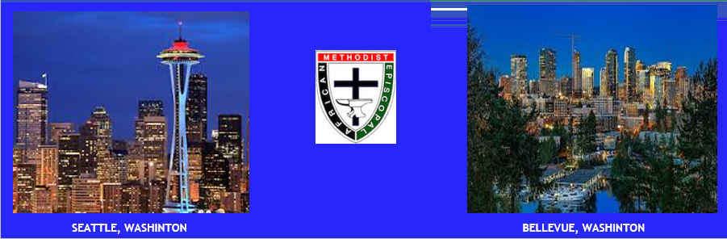
36th Biennial Session – Transportation Options & Guidelines
NOTE: The Host Hotel, Bellevue Hyatt Regency, does not provide airport transportation.
However, below are a few options:

Bellevue Hyatt Hotel Options
- Arrange/Schedule a Shuttle Express through the hotel for $26.00 per person/one way. Please be informed that the Hotel’s Shuttle Express may make additional stops/pickups at other sites.
Booking Online: ShuttleExpress.com
Click Book Now and Provide Detailed Information
- Arrange/Schedule Eagle Town Car/Limousine Service for $85.00 from the airport to the hotel and $65.00 dollars from the hotel to the airport. Please note that there is an additional 20% fee.
Booking Direct: (206) 227-6004 – POC: Mintay
Booking through Hotel: (425) 462-1234 EXT 51 – POC: Any Concierges Available

Paid Public Transportation Options
- Uber Services - $50.00/$60.00 One Way: To use Uber Services, one must download the Uber App onto your smart/mobile phone. Depending upon time of day (traffic impacts) Uber’s fees may vary.
- Lyft Services - $40.00/$50.00 One Way: To use Lyft Services, one must download the Lyft App onto your smart/mobile phone. Depending upon time of day (traffic impacts) Lyft’s fees may vary.
- All Other Public Transportation (Taxi/Yellow Cab…etc.) – Cost May Vary, Please Inquire At Your Own Pace

5th District Lay Transportation Options
IMPORTANT DISCLAIMER: Everyone’s travel request is important to us, however to better manage and sustain a successful travel program; we must place parameters around travel requests and services. The 36th Biennial Sessions begins with an Opening Service on June 30th and the first day of business begins July 1st, there will be limited transportation on those days. Therefore if you will be requesting transportation from the 5th District, please adhere to the travel blocks and schedule/arrange your travel accordingly.
- Friday June 28th 12PM – 9PM from Arrival to the Hotel Site
- Saturday June 29th 8AM – 9PM from Arrival to the Hotel Site
- Sunday June 30th 9AM – 5PM from Arrival to the Hotel Site
- Monday July 1st 8AM - 12PM from Arrival to the Hotel Site
- Thursday July 4th 3PM – 9PM from Hotel to Departure
- Friday July 5th 8AM – 5PM from the Hotel to Departure
36th Biennial Session – Transportation Request Form
NOTE: Please remember to refer to the guidelines and travel restrictions found on the first page. All Travel Requests submitted, requesting travel outside of the restrictions will not be acknowledged.
INSTRUCTIONS:
- Please type or print and return a completed copy to the Travel Team listed below.
- All travel requests for the 36th Biennial Session must be received by 5PM PST - June 10th, 2019.
- Please complete one form per traveler. Do not combine more than one traveler per form.

NAME: __________________________________________
CELL PHONE: __________________________________________
EMAIL: __________________________________________
ARRIVAL AIRLINE/BUS/TRAIN & NUMBER: __________________________________________

ARRIVAL BLOCK & TIME (See Below): __________________________________________
BLOCK AVAILABILITY FOR ARRIVALS
Friday June 28th 12AM – 9PM from Arrival to the Hotel Site
Saturday June 29th 8AM – 9PM from Arrival to the Hotel Site
Sunday June 30th 9AM – 5PM from Arrival to the Hotel Site
Monday July 1st 8AM – 12PM from Arrival to the Hotel Site

DEPARTURE AIRLINE/BUS/TRAIN & NUMBER: _________________________________________
DEPARTURE BLOCK & TIME (See Below): _________________________________________
Thursday July 4th 3PM – 9PM from Hotel to Departure
Friday July 5th 8AM – 5PM from the Hotel to Departure

Please return by June 10, 2019 the completed form via email to both:
Faye Brown: (206) 851-952 & Bobby Brown: (206) 724-9175
36biennialtransportation@gmail.com
Upon Receiving Your Request, you will receive a notification identifying where to meet the travel team at your arrival/departure locations.

