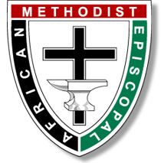
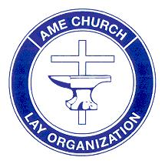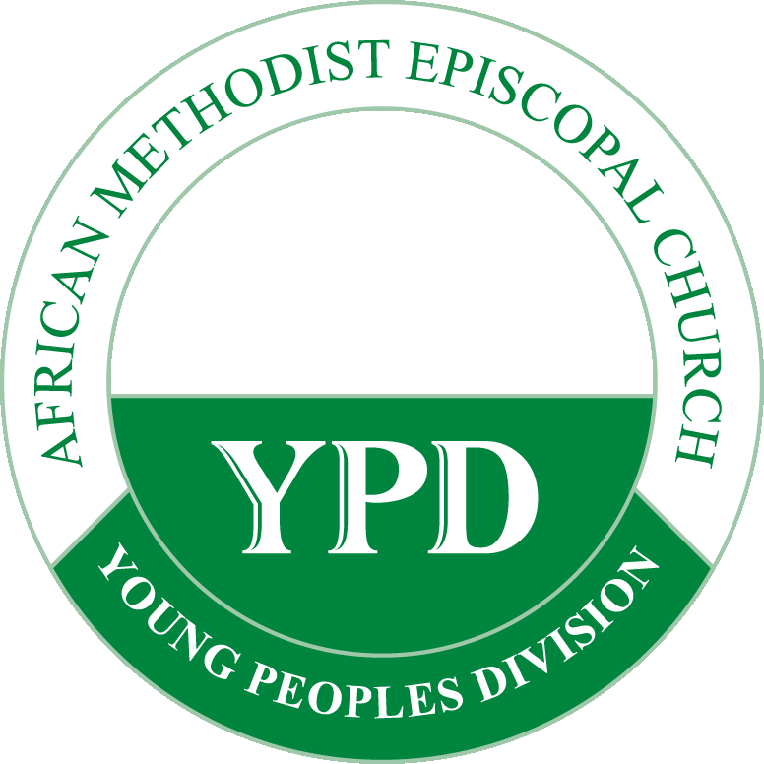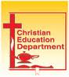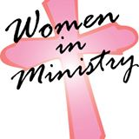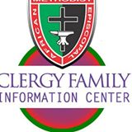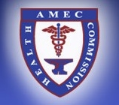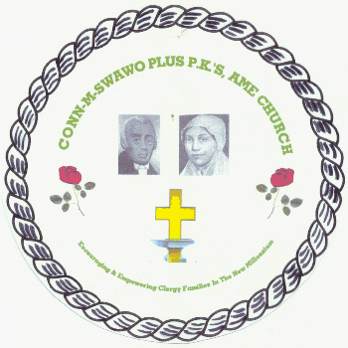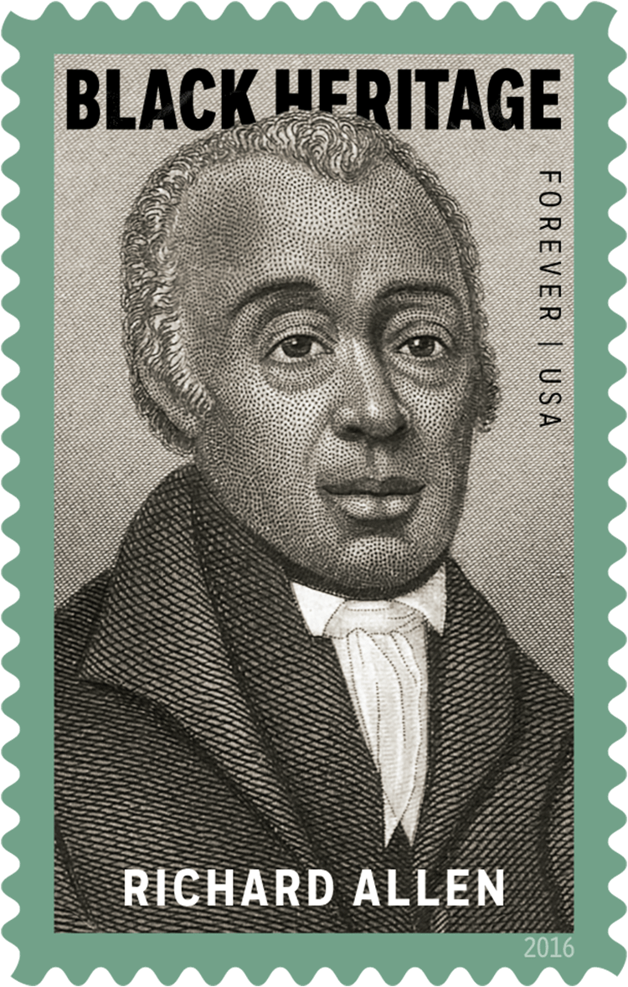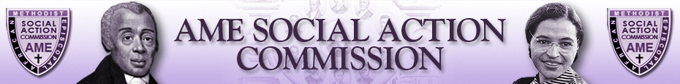

WARD AME CHURCH
1177.W 25th STREET
Los Angeles, CA 90007
Bro. Forest Price ,Local President
Sis. Naima Ogubala, Director of Lay Activities
Rev. John E Cager, III, Pastor

2018 LAY COUNCIL

January 20, 2018

Welcome to the Lay Council of the Southern California Conference Lay Organization!

Welcome to the Lay Council of the Southern California Conference Lay Organization!

What is Lay Council? Lay Council is the teaching & training arm of the SCCLO. We will bring resources to help do the work of preparing laity to minister and serve; to help local lay organizations grow; and to help all deepen their personal relationship with God. It helps the local lay organizations prepare for work in their local congregations.

How do we decide which topic to cover? Each year the Director of Lay Activities circulates a Survey re Training Needs and the recommendations for training topics. The Director, along with the President develop a Plan, using as a guide, the Survey results, the Connectional Training focus (as outlined in the Study Guide), and the AME Church theme (as outlined by the Council of Bishops).

What is the training focus for this conference in 2018? While the annual conference survey has been completed, and the AME Church theme has been outlined, the Connectional Director of Lay Activities is finalizing the Study Guide and focus. Stay tuned for more details at the April 2018 Lay Council; In the meantime, we suggest using the Study Guides and Lay Council lessons and think on these things.
1) Is Your local church/lay organization involved with any Environmental Justice ministry? If so, what? If not, are there any future plans?
2) The General Board (GB) and Council of Bishops ( COB) will meet in Atlanta June 19 – 21, 2017. The Connectional Lay Organization Executive Board will also meet as well as other sessions where you can learn more about how your church operates. Consider these possibilities:

3) What would make this conference year a success in training for the SCCLO?

What is the Lay Council motto? “Get Ready to Report for Duty!”
share, and get ready to “Report For Duty”. Think on these things:

If you have questions or want to talk prior to the Lay Council session, please give me a call at 213-494-9493.
Connectional Theme: “The African Methodist Episcopal Church - A Social Justice and Liberating Faith”

Scripture: “…And what does the Lord require of you But to do justice, to love kindness, And to walk humbly with your God?” Micah 6:8 (NASB)
“But he’s already made it plain how to live, what to do, what God is looking for in men and women. It’s quite simple: Do what is fair and just to your neighbor, be compassionate and loyal in your love; And don’t take yourself too seriously – take God seriously.” Micah 6:8 (Message)

AME CHURCH CONNECTIONAL THEME FOR 2016 – 2020 (Visit www.ame-church.com for details):
TWO YEARS AGO (2016): Political Justice
Voter rights, voter registration, voter education, voter participation, ethnic cleansing, political prisoners, global religious persecution, human trafficking, Black Lives Matter, etc.

LAST YEAR (2017): Criminal Justice Community policing, fair sentencing, prison ministry, prisoner/alumni re-entry, Incarceration policy, juvenile justice, violence, addictions, human trafficking, family disruption, etc.

THIS YEAR (2018): Environmental Justice
Climate change, hazardous waste, clean water, water availability, pollution, and sustainable development, off- shore drilling, fracking, greening of the home and sanctuary,

NEXT YEAR (2019): Economic Justice
Fair wages, job opportunity and training, HBCU’s and AME Schools, the digital divide, technical training, sustainable development, family economics

CALL TO ORDER: Sistah “Jackie” Dupont-Walker, SCCLO Director of Lay Activities

OPENING (TODAY’S THEME SONG): “In The Garden”

Read the words and join in this testimonial hymn. Methodists have been known for singing with great fervor and joy:

Verse #1
I come to the garden alone, While the dew is still on the roses,
And the voice I hear, falling on my ear, The Son of God discloses.
And He walks with me, and He talks with me,
And He tells me I am His own,
And the joy we share as we tarry there,
None other has ever known.
Verse #2
He speaks, and the sound of His voice, Is so sweet the birds hush their singing,
And the melody that He gave to me, Within my heart is ringing.
And He walks with me, and He talks with me,
And He tells me I am His own,
And the joy we share as we tarry there,
None other has ever known.
Verse #3
I'd stay in the garden with Him, Tho' the night around me be falling,
But He bids me go, thro' the voice of woe, His voice to me is calling.
And He walks with me, and He talks with me,
And He tells me I am His own,
And the joy we share as we tarry there,
None other has ever known.

PRAYER:

SCRIPTURE: John 13:34–35 (Please read in unison.)
“I give you a new commandment, that you love one another. Just as I have loved you, you also should love one another. By this everyone will know that you are my disciples, if you have love for one another.” (NRSV)

LITANY: LITANY FOR SERVANT LEADERS & MEMBERS
GOD – I WILL……….
LEADER: It’s time for some “straight talk”. For the record: If there are limits on what God can do, those limits would be self-imposed by us.
PEOPLE: Now hold on…Would I place limits on God, who is omnipotent, who is omnipresent?
LEADER: Well, do you remember that Jesus could do very few miracles in his hometown, not because his power was restrained in that place, but because the people there would not believe and allow him to release his power to help them.
PEOPLE: No, no, I believe that Jesus was God in the flesh and I know that God can do anything. I profess that every Sunday. I promise to do better every day. So I’m on the right track, right?
LEADER: Do you remember that doing God’s will without knowing the outcome is “Faith”. Our God touches the hills and they tremble; God touches the thief and he or she repents. God’s word instructs us to give when we don’t know how and we prosper. God provides before we know what we need.
PEOPLE: I believe. So, my prayers will be for God to take control. I will stop expecting God to respond to small requests generated by small dreams. I believe that God is awesome, so I will not hesitate to dream big, beyond MY ability to make it happen.
LEADER: Is there any job God begins that God cannot finish? Is there any task too hard for God to complete?
PEOPLE: No, God can finish everything! God can complete any task!
ALL: So let us declare this day. God, we believe you can finish the work in each of us… helping us to truly love one another. ..making THIS AME Church a serving station for the people and community. Mighty God, Let us be the evidence of harvest and the fruit of discipleship in our life’s walk, in our home, in our church, and our community. God, this day, we reject our small dreams of yesterday, and move boldly by faith into limitless dreams for YOU to be glorified in our daily walk. God, this day, do everything you desire in me. God, this day, I will give up what I think to do YOUR will, and in the days ahead, God I am completely and totally yours! AMEN (Prayerfully written by Sistah “Jackie” Dupont-Walker based on James 2:14, 4:2 – any translation)

ROLL CALL: (Secretary to be elected)

THE LESSON: “Caring Enough to Share” (Everything DMV wants our Elders to Know)
Ms. Tressa Thompson, Senior Driver Ombudsman – DMV of State of California
(Los Angeles and Central Coastal Counties

REMARKS: Lay Activities Director “Jackie” Dupont-Walker
President Dorothy Vails Weber

ADJOURN TO SCCLO EXECUTIVE BOARD:

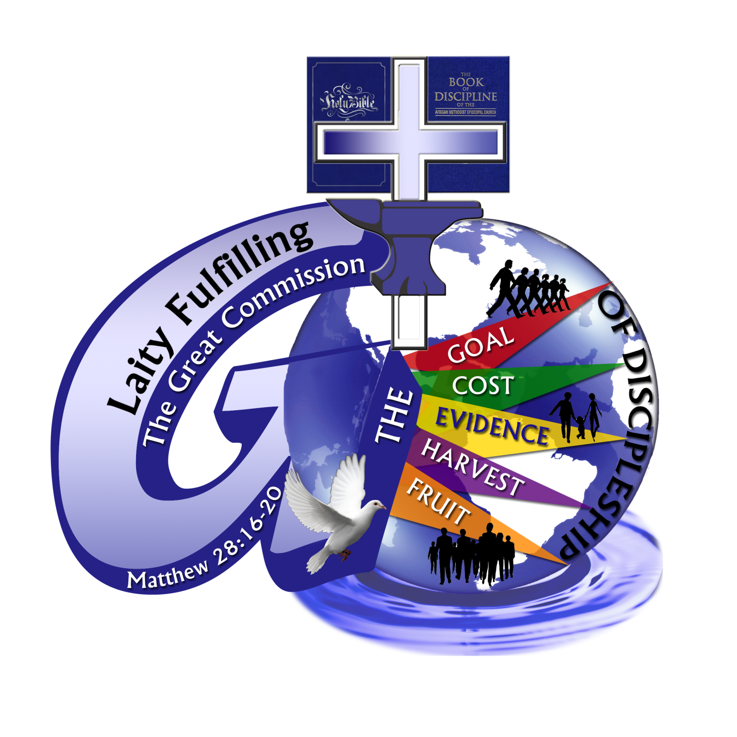
Thanks to the Grant AME Church Family, under the shepardship of Pastor Rumph, for hosting this inaugural Lay Council sesión for 2016. Thanks to each of you for engaging in this learning experience. Take what you’ve learned, make it your own, and share it with the folk at your home church.

New Logo for Conntectional Lay Organization’s current Theme

